|  |  |  |  |
| --- | --- | --- | --- |
| **Lyng Primary School Knowledge Organiser** | | | |
| **Topic:** | **Victorians**  **Case study of the UK**  **What can you find in the UK?** | Year 4  Battles, beliefs and buildings | Spring- Summer |

 

|  |  |
| --- | --- |
| **What Step On and Goldilocks words will I use?** | |
| **Spelling** | **Definition** |
| Human geography | How human activity is affected by the environment. |
| Physical geography | A study of the natural features on the surface of the earth. |
| County | The way a country can be divided with its own local government. |
| Britain | The United Kingdom |
| Capital city | The most important town or city of a country or region, where the government operates from. |
| Loch | Scottish word for lake |
| global | relating to the whole world. |
| population | all the people living in a particular country, area, or place: |
| continent | one of the seven large land masses on the earth's surface, surrounded, or mainly surrounded, by sea and usually consisting of various countries. |
| country | an area of land that has its own government, army, etc. |
| Worldwide | existing or happening in all parts of the world. |

**Background information for parents and teachers.**

The United Kingdom is a country in northwestern Europe. It consists of four countries: England, Scotland, Wales and Northern Ireland. It is located mainly on two large islands in the Atlantic Ocean and no location in the UK is farther than 125km/77 miles from the sea.

The UK is slightly smaller in size than Oregon in the USA and slightly bigger than Ghana. Its landscape consists mainly of rolling plains and rugged hillsides.

The UK has 13 British overseas territories among them are the Cayman islands and British Virgin Islands in the Caribbean, Gibraltar on the Iberian Peninsula and Saint Helena in the South Atlantic Ocean.

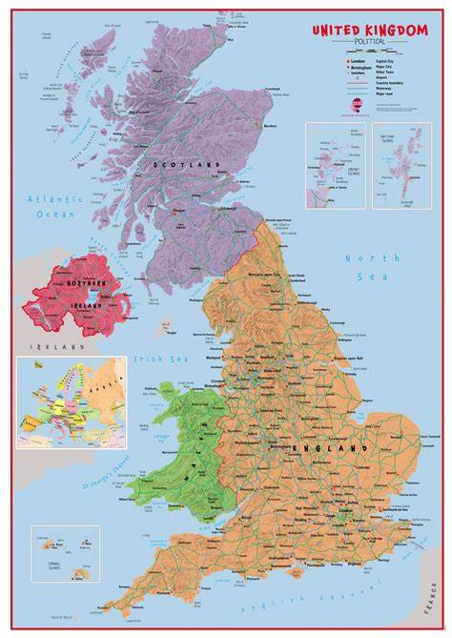

**Fieldwork Opportunities**

Out into the local area

Sandwell valley



**Significant places**

* England
* Scotland
* Wales
* Northern Ireland
* Cardiff
* London
* Edinburgh
* Belfast

|  |
| --- |
| **Geographical study** |
| Ask and answer geographical questions about the physical and human characteristics of a location.  Explain own views about a location, giving reasons.  Use maps, atlases and globes to locate countries and describe features. Describe the geographical similarities and difference between countries.  Name and locate counties and cities of the United  Kingdom.  Describe geographical similarities and differences between countries. |

**Our Storytelling Approach to enhance engagement**

|  |  |  |
| --- | --- | --- |
| **People:**  Street Child. | **Place:**  Slums/ Workhouse. East End, London. | **Problem:**  How do I escape the workhouse? |

**Key facts and locations**

**Map to be studied**

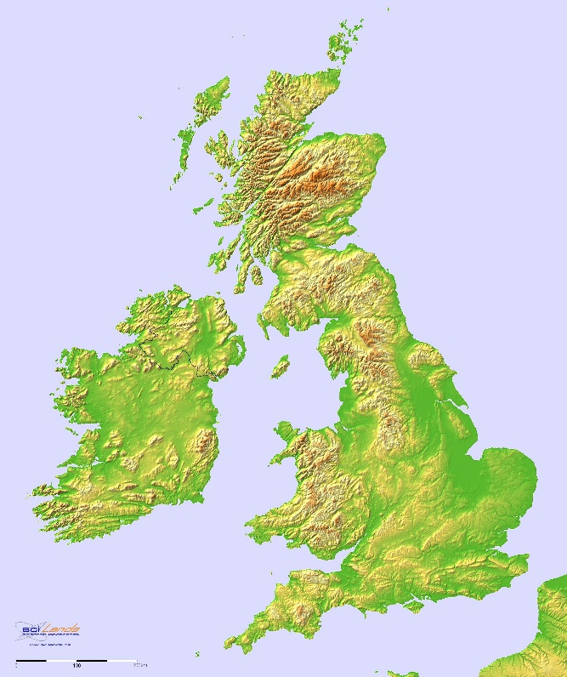

The largest country of the UK is England. The smallest country is Northern Ireland.

The UK has the third longest coastline in Europe with 12,430km/7,723 miles after Norway and Denmark (Greenland)

The United Kingdom’s highest mountain is Ben Nevis in Scotland at 1,345m/4,412ft.

The largest lake in the UK is Lough Neagh in Northern Ireland.

Loch Ness is the largest fresh water lake in the UK.

The longest river in the UK is the River Severn at 354km/220 miles.

**Agreed Outcome**

A greater understanding of the four countries of the UK.

|  |  |  |  |
| --- | --- | --- | --- |
| **Lyng Primary School Knowledge Organiser** | | | |
| **Topic:** | **Victorians.**  **Human and Physical Geography** | Year 4  *Battles, Beliefs and Buildings* | Spring- Summer |

|  |  |  |
| --- | --- | --- |
| 5. Which county do we live in? | **S** | **E** |
| 1. Birmingham |  |  |
| 1. West Midlands |  |  |
| 1. Warwickshire |  |  |

|  |  |  |
| --- | --- | --- |
| 6. Can you name three rivers in England? | **S** | **E** |
|  |  |  |
|  |  |  |
|  |  |  |

|  |  |  |
| --- | --- | --- |
| 7. Which country in the UK is the smallest? | **S** | **E** |
| 1. Scotland |  |  |
| 1. Wales |  |  |
| 1. Northern Ireland |  |  |

|  |  |  |
| --- | --- | --- |
| 8. What physical geographical feature would you find at the Lake District? | **S** | **E** |
| 1. Mountains |  |  |
| 1. Rivers |  |  |
| 1. Lakes |  |  |

|  |  |  |
| --- | --- | --- |
| 1. What is the name of the capital city of Scotland? | **S** | **E** |
| 1. Belfast |  |  |
| 1. Cardiff |  |  |
| 1. Edinburgh |  |  |

|  |  |  |
| --- | --- | --- |
| 2. Which of these is an example of Human Geography? | **S** | **E** |
| 1. Lakes |  |  |
| 1. Villages |  |  |
| 1. Mountains |  |  |

|  |  |  |
| --- | --- | --- |
| 3. Where would you find Ben Nevis? | **S** | **E** |
| 1. Wales |  |  |
| 1. Scotland |  |  |
| 1. England |  |  |

|  |  |  |
| --- | --- | --- |
| 4. Name three cities in England | **S** | **E** |
| 1. |  |  |
| 2. |  |  |
| 3. |  |  |